**EE5176: Computational Photography**

**Programming Assignment 3**

**Name:** Mohammad Al Fahim K **Roll No.:**EE21S050

1. **Camera Response Function Estimation**

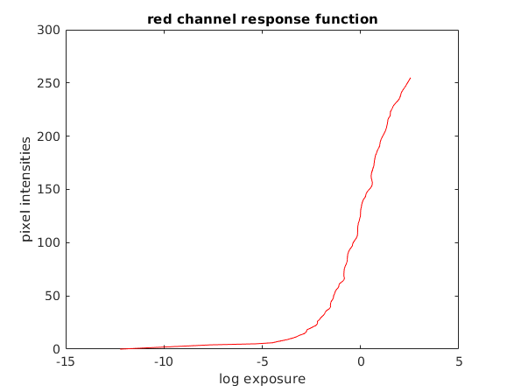

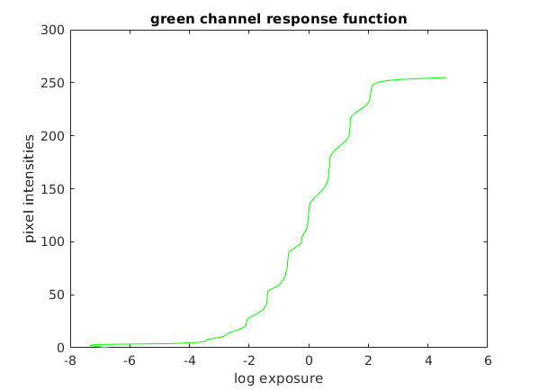

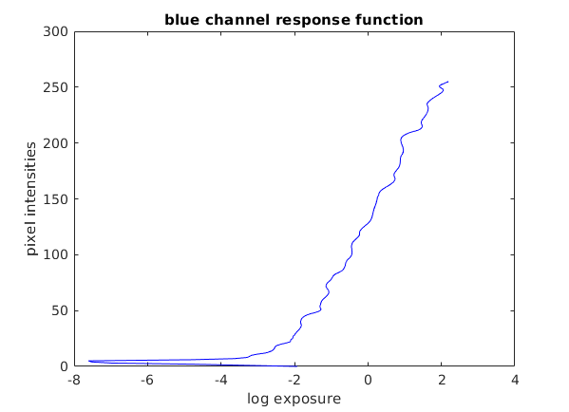

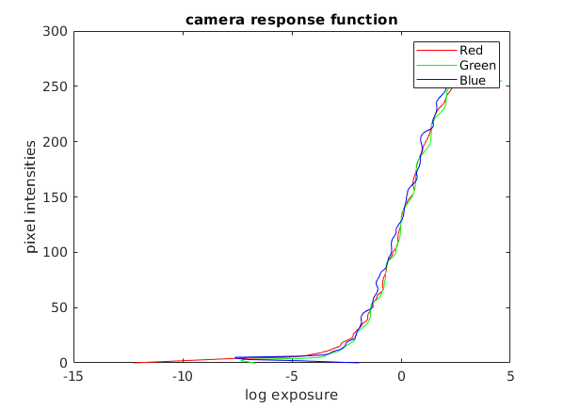

1. **Constructing the HDR Radiance map**

The HDR Radiance map was constructed but the library required to write the radiance map as exr file could not be installed. Hence, it was saved in the matlab supported hdr format.

1. **Photographic Tone-mapping**
2. *When I_white = ∞*

When K was below 0.3, although left side brighter regions looked better, the objects in the right side darker regions could not be discerned easily. So the chosen K values are 0.3, 0.5, 0.7

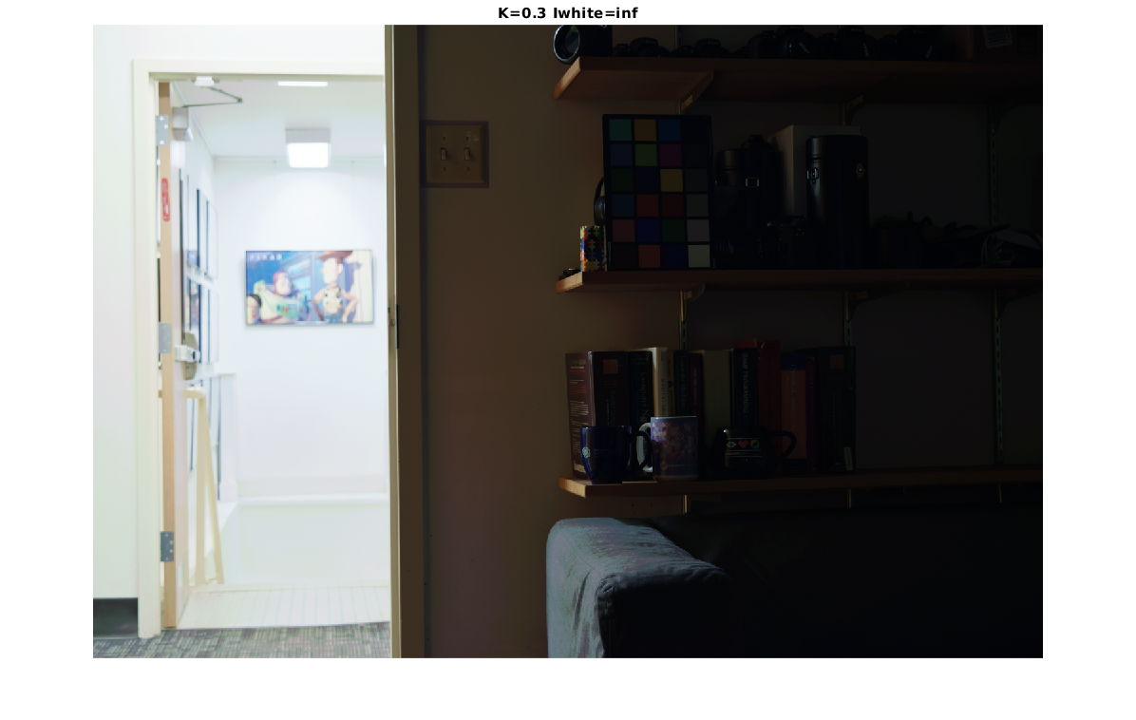

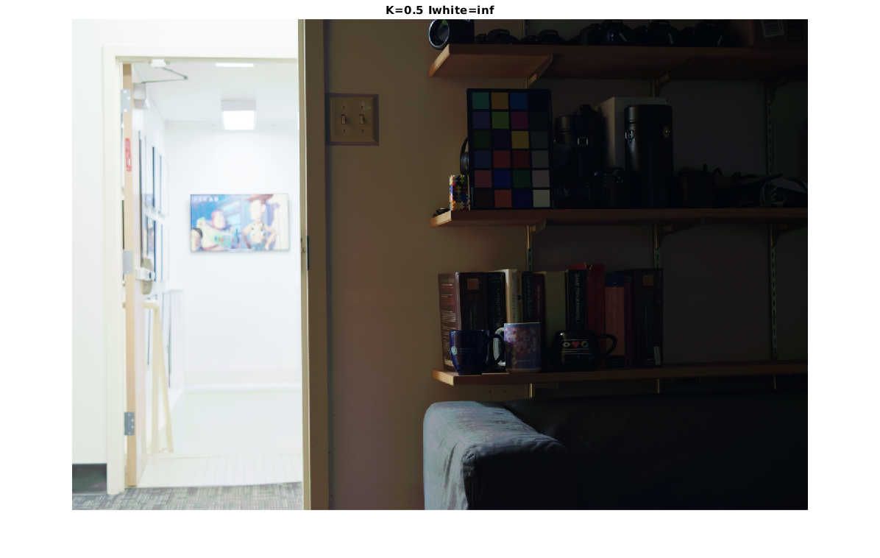

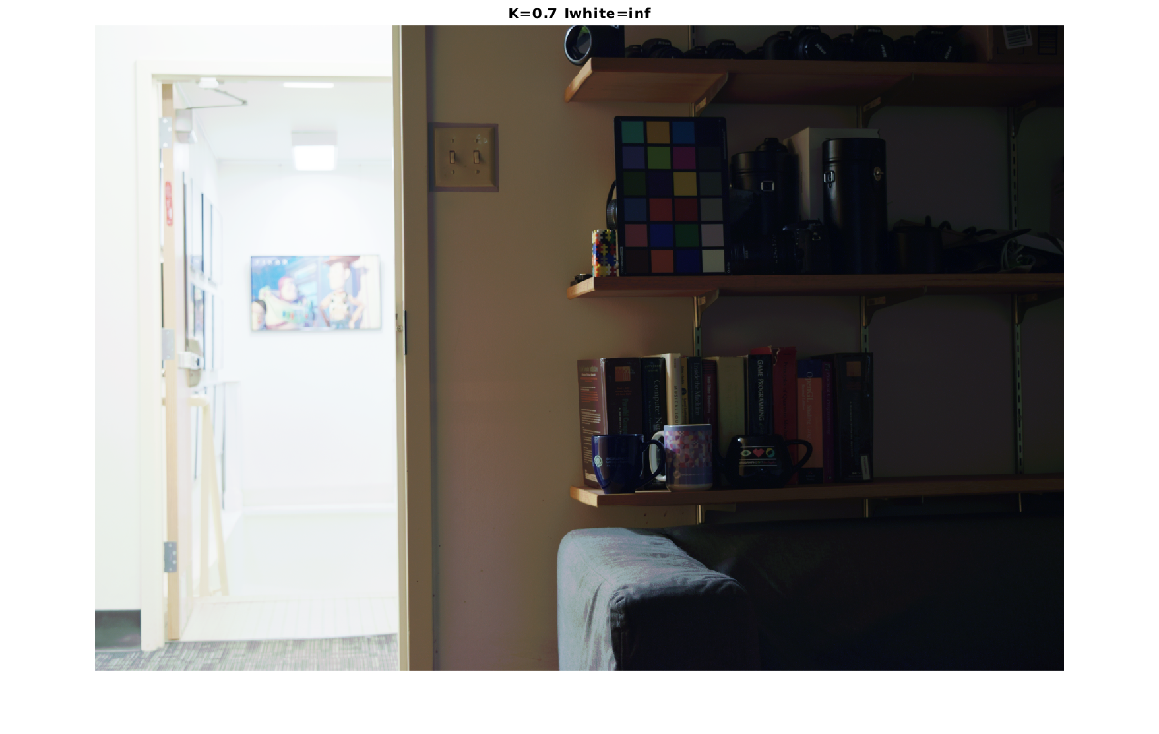

1. *When I_white ≠∞*

Altering the B values does not make much visual difference. The K value had a bigger impact than B on the intensity of the images.

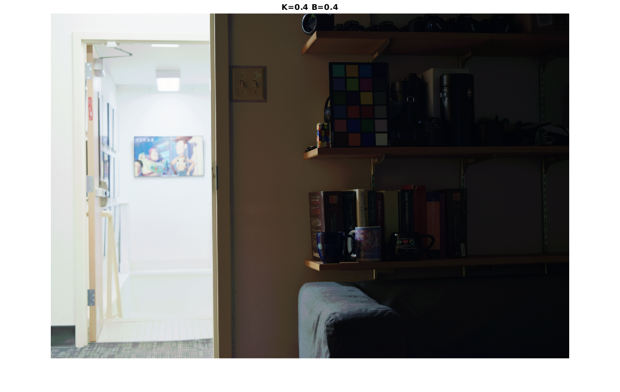

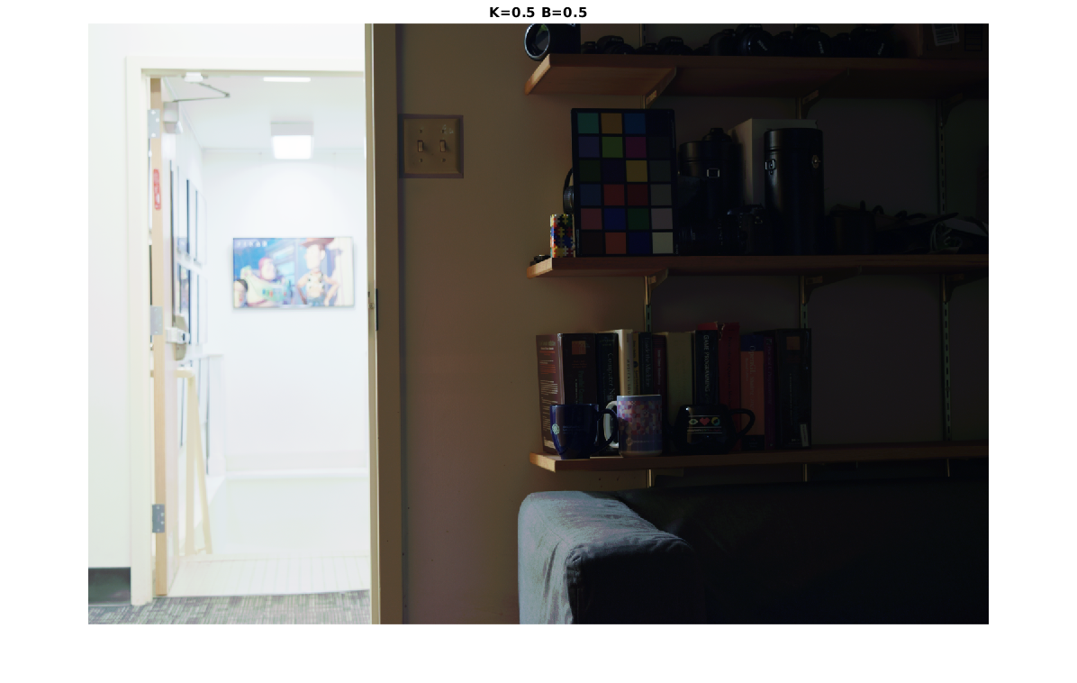

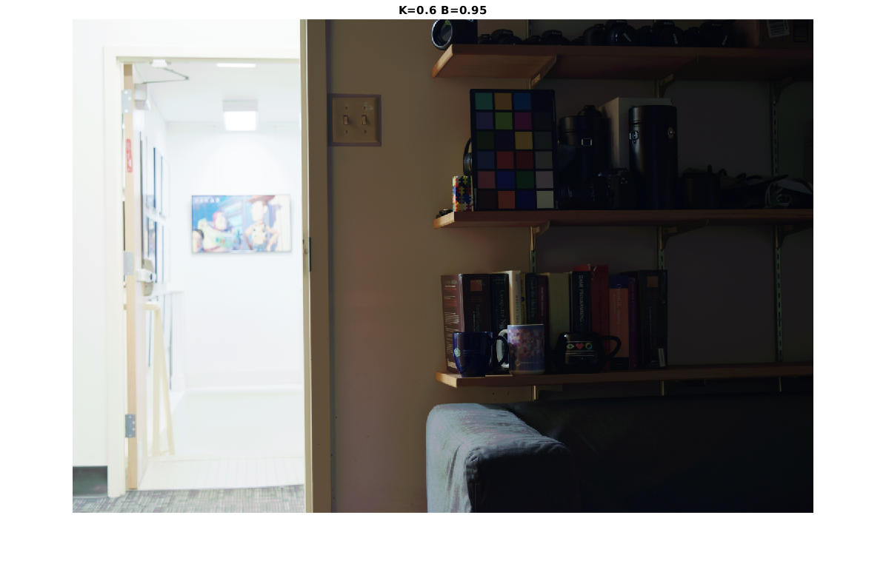

1. Increasing the K values increases the overall brightness of the image due to which the brighter regions of the image tend to get over-exposed and saturated. It is because K and Ibar_hdr are directly proportional and directly affect the final intensity of the scale of the resulting image.

When setting I_white ≠ ∞, the brightness of the darker regions of the image increses slightly, when observed closely with the previous case's images. Therefore, changing B varies the lower limit of the intensity scale of the resulting images.

When setting B ≤ 0.1, the overall intensity of the image drops down drastically, much lower than when I_white = ∞.

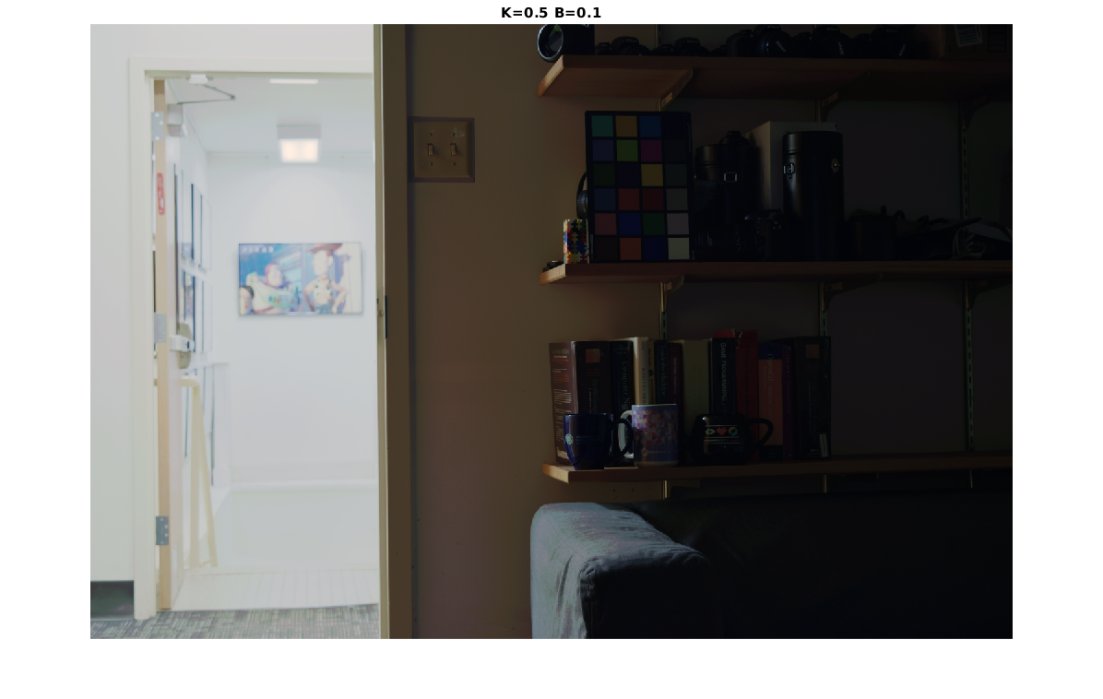

Notice the how the brightness of the leftmost brighter regions have dropped down significantly then the previous images. And now in the below image, the overall intensity has dropped down drastically.

